Question : 1
Given a CSV file containing Zomato restaurant ratings, use pandas to detect outliers in the 'user_rating' column using the IQR method and print the indices of the detected outliers :

import pandas as pd
df = pd.read_csv("Lib/Zomato_restaurants_small.csv")
Q1 = df["user_rating"].quantile(0.25)
Q3 = df["user_rating"].quantile(0.75)
IQR = Q3 - Q1
lower_bound = Q1 - 1.5 * IQR
upper_bound = Q3 + 1.5 * IQR
outliers = df[
(df["user_rating"] < lower_bound) |
(df["user_rating"] > upper_bound)]
print("Outlier indices:")
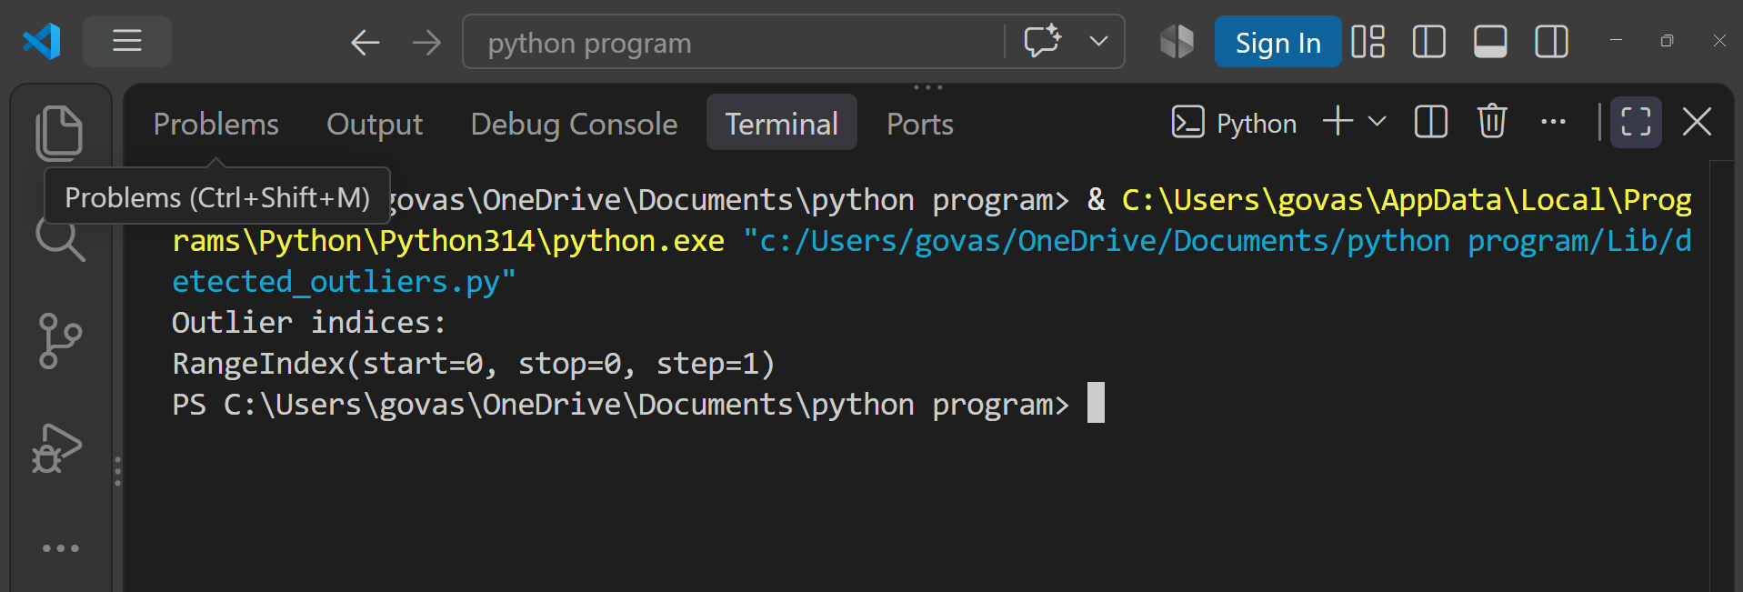
print(outliers.index)
Question : 2
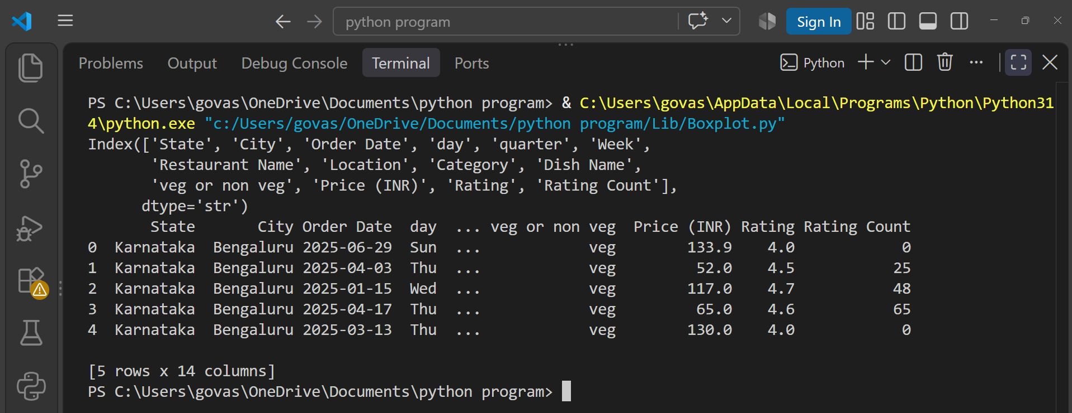
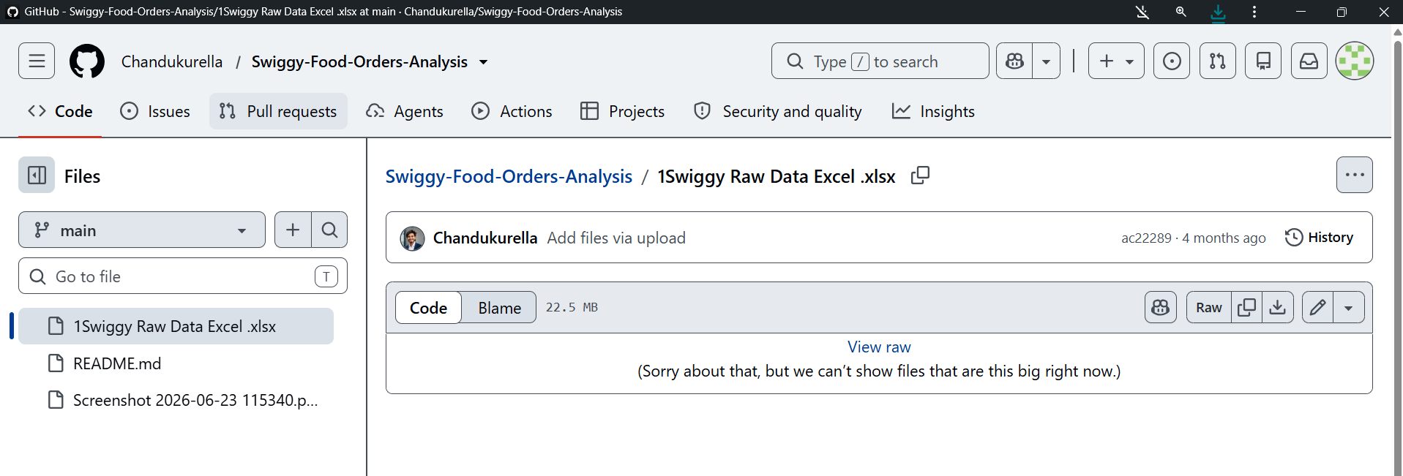
Create a boxplot for the 'order_amount' column from a Swiggy orders dataset using matplotlib, and visually identify any outliers present.<br><br><em><strong>Hint:</strong> Use plt.boxplot() and label your axes for clarity : </em>

import pandas as pd
import matplotlib.pyplot as plt
df = pd.read_excel(
"Lib/1Swiggy Raw Data Excel .xlsx",
sheet_name="Swiggy Data"
)
plt.boxplot(df["Price (INR)"])
plt.xlabel("Swiggy Orders")
plt.ylabel("Order Amount (INR)")
plt.title("Swiggy Order Amount Boxplot")
plt.show()
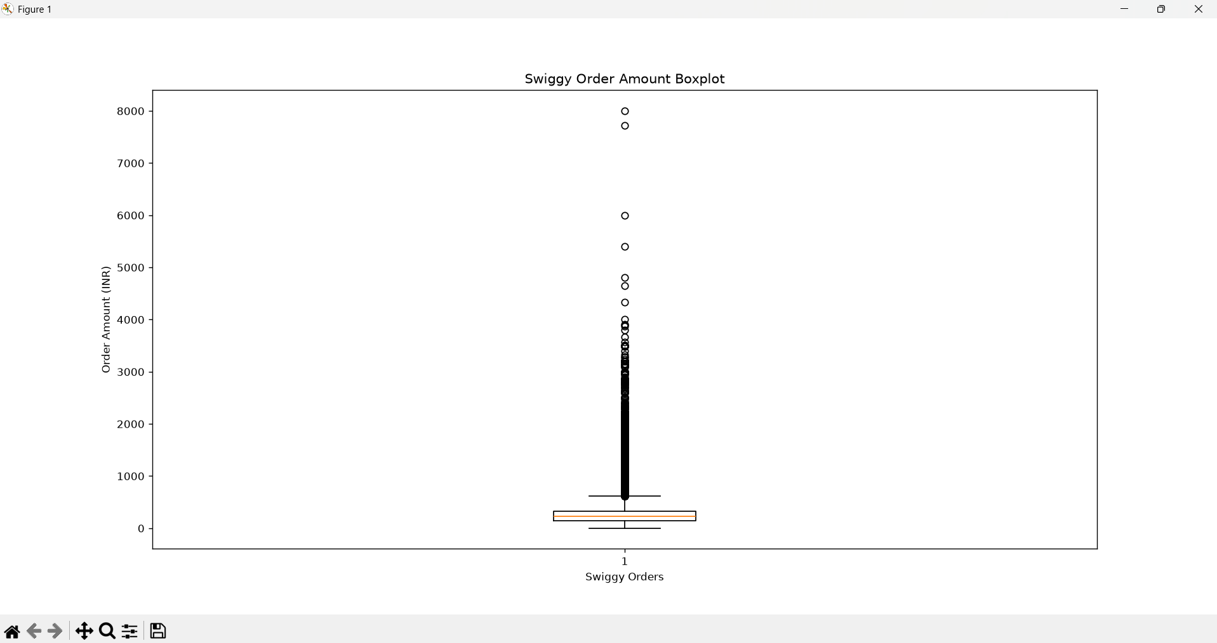
Question : 3
Apply winsorization to the 'transaction_amount' column in a Paytm transactions DataFrame to cap all values above the 95th percentile and below the 5th percentile, then display the updated column statistics :

import pandas as pd
df = pd.DataFrame({
"transaction_amount": [100, 250, 300, 450, 500, 700, 900, 1200, 1500, 5000]
})
lower = df["transaction_amount"].quantile(0.05)
upper = df["transaction_amount"].quantile(0.95)
df["transaction_amount"] = df["transaction_amount"].clip(
lower=lower,upper=upper)
print("Updated statistics:")
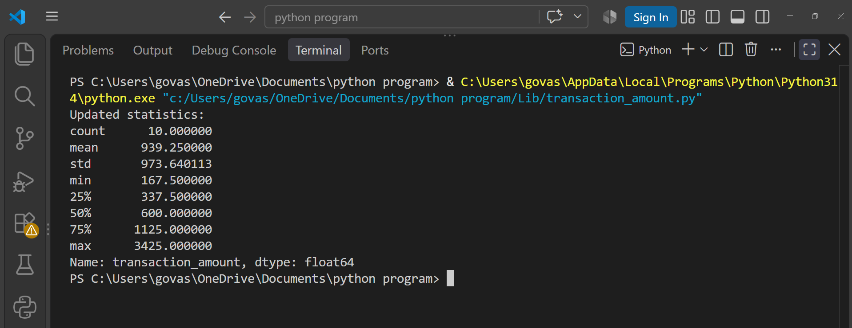
print(df["transaction_amount"].describe())
Question : 4
You have a DataFrame of Flipkart product prices stored as strings with currency symbols (e.g., '₹1,299'). Convert this column to numeric type using pandas, ensuring all non-numeric characters are removed.<br><br><em><strong>Hint:</strong> Use str.replace() and astype() : </em>

import pandas as pd
df = pd.DataFrame({
"product": ["Product A", "Product B", "Product C", "Product D"],
"price": ["₹1,299", "₹899", "₹2,499", "₹599"]
})
df["price"] = df["price"].str.replace(r"[^\d.]","", regex=True).astype(float)
print(df)
print("\nPrice data type:")
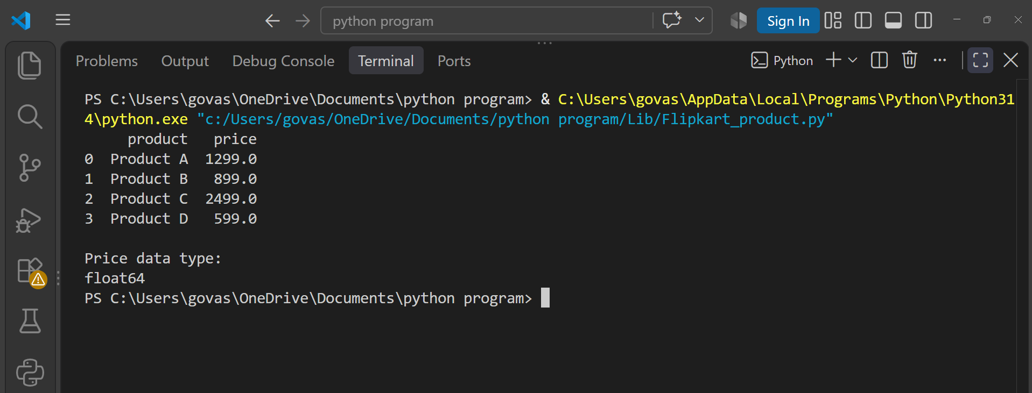
print(df["price"].dtype)
Question : 5
Fix the following code snippet where the 'is_premium' column in a Spotify user DataFrame is a mix of boolean, string, and integer types. Convert the entire column to boolean type, treating 'True', 1, and 'yes' as True, and everything else as False :

import pandas as pd
df = pd.DataFrame({
"is_premium": [True,"True",1,"yes",False,"False",0,"no","random"]
})
df["is_premium"] = df["is_premium"].apply(
lambda x: True if x is True or x == "True" or x == 1 or x == "yes" else False)
print(df)
print("\nData type:")
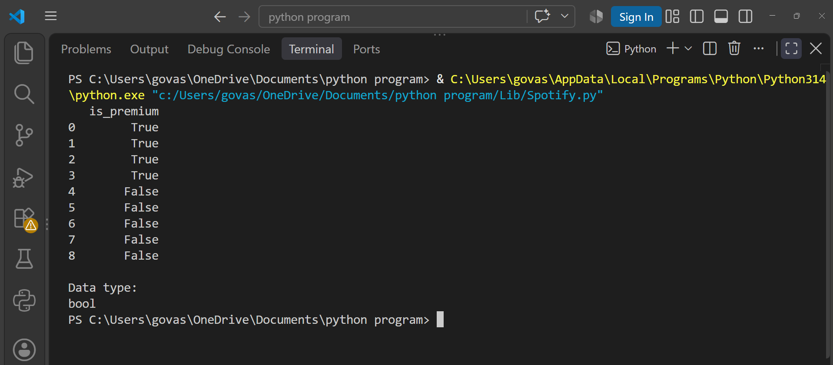
print(df["is_premium"].dtype)

